import seaborn as sns
import matplotlib.pyplot as plt

days = ['Mon', 'Tue', 'Wed', 'Thu', 'Fri', 'Sat', 'Sun']
temps = [32, 34, 33, 35, 36, 37, 34]

sns.lineplot(x=days, y=temps)

plt.xlabel("Days")
plt.ylabel("Temperature")
plt.title("Weekly Temperature Trend")

plt.show()
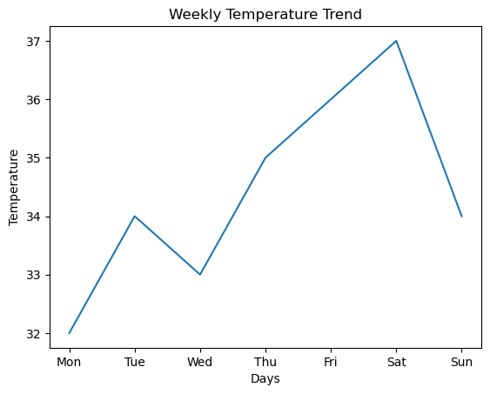
sns.set_theme(style="darkgrid")

sns.relplot(
x=days,
y=temps,
kind="line"
)

plt.xlabel("Days")
plt.ylabel("Temperature")
plt.title("Weekly Temperature Trend")

plt.show()
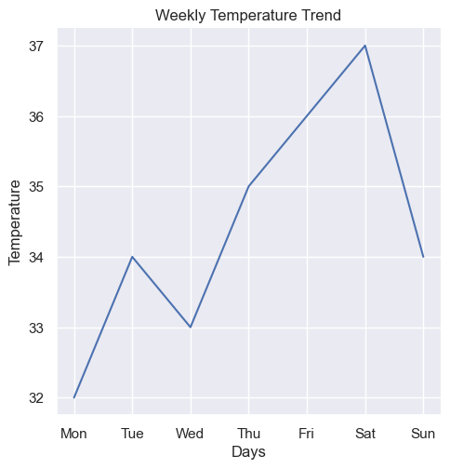
sns.set_theme(style="darkgrid")

sns.lineplot(x=days, y=temps)

plt.xlabel("Days")
plt.ylabel("Temperature")
plt.title("Weekly Temperature Trend - Darkgrid")

plt.savefig("temperature_darkgrid.png", bbox_inches="tight")
plt.show()
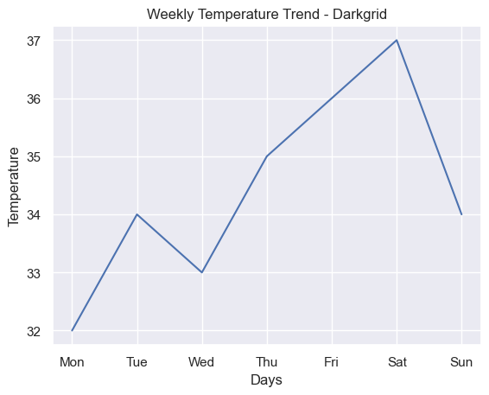
sns.set_theme(style="whitegrid")

sns.lineplot(x=days, y=temps)

plt.xlabel("Days")
plt.ylabel("Temperature")
plt.title("Weekly Temperature Trend - Whitegrid")

plt.savefig("temperature_whitegrid.png", bbox_inches="tight")
plt.show()
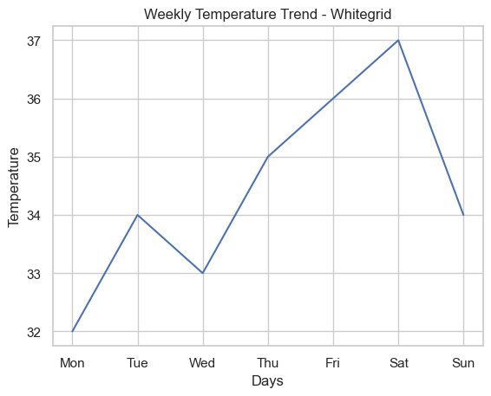
sns.set_theme(style="ticks")

sns.lineplot(x=days, y=temps)

plt.xlabel("Days")
plt.ylabel("Temperature")
plt.title("Weekly Temperature Trend - Ticks")

plt.savefig("temperature_ticks.png", bbox_inches="tight")
plt.show()
